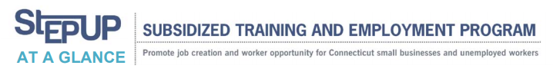

WHAT:
Step Up offers two incentives – a Small Manufacturing Training Grant and Wage Subsidy – to help eligible businesses in the state hire more employees. Over a six-month period, Step Up can provide up to $12,500 for each new employee to help defray costs of hiring or training. New employees must be unemployed jobseekers; those hired under the wage subsidy program need to meet certain income requirements and reside in specific municipalities, based on population or unemployment rates.
The program was expanded in June 2012 to include retail establishments and small businesses with up to 100 employees (previously it was up to 50). The expansion has allowed more employers to participate in the program.

PARTICIPANTS (as of July 2013):
• • Employers currently taking part in the program: 504
• New employees hired under the program: 1,675
870 hired under the Small Manufacturing Training incentive
805 hired under the Subsidized Wage incentive

BY THE NUMBERS:
• As part of the October 2011 Jobs Bill, the Legislature authorized $5 million a year for two years ($10 million total) for the Subsidized Wage program and $5 million a year for two years ($10 million total) for the Small Manufacturer Training program.
• Average employer reimbursement: approximately $10,800 per new employee
• Average hourly wage: approximately $14.30

WHERE ARE THE JOBS?
Positions include plant operators, engineers, warehouse support, office assistants, sales representatives, marketing support, CAD designers, CNC operators, machine operators, carpenters, production coordinators, customer service representatives and graphic designers.

For more information, please call Eastern CT’s STEP UP Coordinator:
Linda Riquier
LRiquier@qvcc.edu
(860) 455-1555

